PRESIDENT'S DAY
SATURDAY SEPT 4th AT 2.00 p.m.

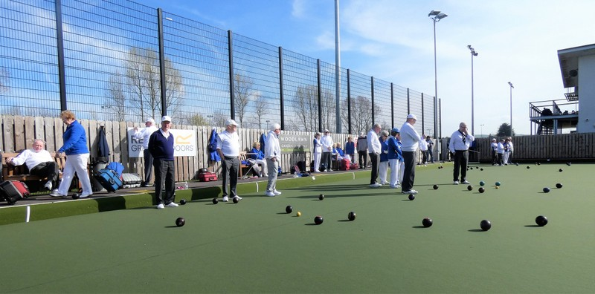

Irene's President's Day has been a long time coming but it is planned for Sat 4th Sept at 2:00 p.m.

There will be a tournament for all in the afternoon, followed by a Finger Buffet and 'scrumptious deserts' at approximately 5:30 p.m. in the Greeves Room. Should the weather be poor the Buffet may be earlier.

As you will appreciate, we need to know who will be attending for catering purposes. It is essential that you contact me before Friday 27 Aug at the Caterer’s request. Numbers may be limited, so bookings will be on a first-come, first-served basis.
*Should anyone change their mind after booking, could they please let me know as places will be allocated to those on the waiting list.

President Irene's prizegiving will follow the meal.

Cost: £10.00

Dress code: Ladies: white trousers and Club or white shirt.
Gentlemen: grey trousers and Club or white

Please pay any member of the Committee by 31ST August to reserve your place

Mobile: 07849650522 email: nan.mcbride@aol.com

Nan
P.S. Masks should be worn when moving around inside CIYMS .

