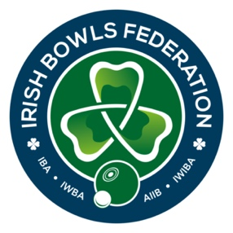

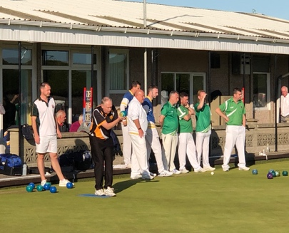

LAWN BOWLS IN NORTHERN IRELAND
&
COVID-19 GUIDELINES

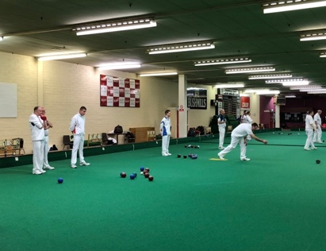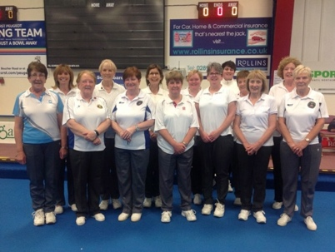

(From 1st April 2021)

Irish Bowls Federation
Social Distancing and Guidelines for Safe Play
- Club Responsibilities
  - Clubs should be fully aware and compliant with NI Government legislation and they should ensure that these guidelines are adhered to.
https://www.nidirect.gov.uk/campaigns/coronavirus-covid-19

https://www.nidirect.gov.uk/publications/coronavirus-covid-19-guide-restrictions-0

It should be noted if the club is at a Council green their may be local rules and
regulations to follow.
  - Appointed club member(s) will prepare the green for play, delivering equipment to the playing rinks with hygiene in mind and disinfected for safe use by bowlers. After the game this equipment should be disinfected again before it is returned to storage.
  - Rink time should be booked with the club before attending to play.
Individuals must leave the premises immediately after the conclusion of play and cleaning of equipment.
  - Sanitiser and disinfectant to be made available to all bowlers.
  - Clubhouses should remain closed. Safe access to toilet facilities is permitted.

- Player Responsibilities
  - Player Health
2.1.1 All players who have tested positive or in isolation for Covid-19 or are living in the same household with a Covid-19 positive person should adhere to the following:
- If you are unwell or have symptoms stay at home
- If you have tested positive and are in self isolation you may not return to bowling for a minimum of 10 days, as per NI Government guidelines;
- or until you have returned a negative test and are symptom free, as per NI Government guidelines
- If you are living in the same household with a Covid-19 positive person, you must also follow (ii), as per NI Government guidelines.
- Players who have symptoms should notify their club, if they were due to play, and start self-isolation for 10 days or until a negative test is returned and they are symptom free, whichever is the least amount of time.
- Players who travel to and from the bowling club must be independent from other non-household participants unless social distancing can be maintained.
    - All players should practice safe hygiene at all times, including washing hands for at least 20 seconds before and after bowls.
    - Pre-game and post-game handshakes and other gestures that involve contact with other bowlers are not allowed.

  - Attire and Equipment
    - Club attire for matches to be optional, bowling shoes will remain mandatory.
    - All bowlers must arrive to the bowling green in attire suitable for bowling, changing on the premises is not allowed.
    - Bowlers are allowed only one bag and an umbrella at the green attended.
    - All equipment to be used i.e. measures etc. should be disinfected before being used
    - Disinfectant spray must be available beside mat/jack boxes and between each game, all mats and jacks must be thoroughly cleaned by players before and after use.

- On the Green
  - Mat, Jack, Bowls and Scoreboard
    - Under no circumstances should players arrive at the club to play without booking. Best practice is that a register of attendees is kept, just in case a communicable illness was to occur.
    - Players should not arrive more than 15 minutes before booked time
    - Players must leave immediately at the conclusion of playing time
    - Minimum mat placement to be three metres from the ditch.
    - Spray chalk to be the only way to mark bowls that have made contact with the jack.
    - A player will not have control of the mat until the previous player is at least 2 metres from the mat.
    - Each lead will have a jack and mat supplied to them by the club which should only be used by that lead. Mat should be carried up and down green by that lead.
For casual roll ups consider placing the jack rather than delivering it.
    - In the event of a foul jack or bowl that has left the rink or fallen into the ditch, the jack/bowl is to be removed by one designated player and placed on the bank using a cloth.
    - Centring of the jack should be done by foot.
    - Players must only use and touch their own bowls.
    - When a count has been decided, bowls to be removed either by the owner of the bowls or by removing them by foot.
    - All bowlers must have a cloth with disinfectant/sanitiser to apply to each bowl and jack before and after each game.
    - Measuring will be done by one player on each rink predetermined by team captains.
    - One designated player to keep the scoreboard updated. Ideally use scorecards rather than scoreboards.

    - From 1st April - Maximum of 10 players from no more than 2 households are permitted on the green. Maximum of 4 players on each rink. Alternate rinks should be used.

From 12th April - Maximum of 15 players will be allowed on the green with no restriction on number of households. Maximum of 6 players on each rink. Alternate rinks should be used.

  - General Social Distancing Guidelines

    - Each bowler will remain at all times at least two metres from all other bowlers, with outer rinks and bank space to be utilised in doing so.
    - Bowlers will travel up the green in the middle and utilise vacant rinks available for standing and walking up and down to the head. Should an adjacent rink be in use and players are walking to and back from the head, you must wait for them to stop before walking to the other end of the green.

- Spectators

  - Spectators are not allowed unless the adherence of appropriate social distancing can be practiced.

