MIXED RINKS TOURNAMENT
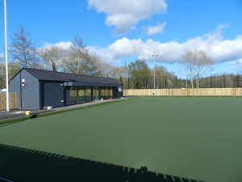
AT CI-KNOCK
SPONSORED TOURNAMENT

9TH – 13TH APRIL 2018
ROUND ROBIN MON-TUES-WED EVENINGS
(3 games per rink)
QUARTER -FINALS AND SEMI-FINALS THURS EVENING
FINAL AND 3RD/4TH PLAY-0FF FRIDAY EVENING
ENTRY LIMITED TO THE FIRST 32 RINKS APPLYING
(Maximum 2 rinks per club)
ENTRANCE FEE £20.00 PER RINK (payable to CI-Knock with entry)
RINKS MUST BE MIXED BUT IN ANY COMBINATION
DRESS CODE:- WHITE OR CLUB TOP/GREYS

FIRST PRIZE £200
RUNNER-UP £100
THIRD £80
FOURTH £40

PLEASE SEND ENTRIES (with contact details including e-mail) TO
CHARLIE COSTLEY
20 MILLMOUNT VILLAGE WAY
DUNDONALD BT16 1AL
07802945035
charliecostley@hotmail.com

